HTTP Result

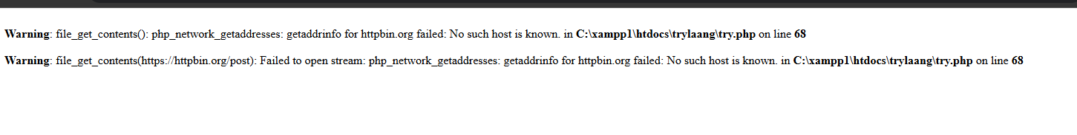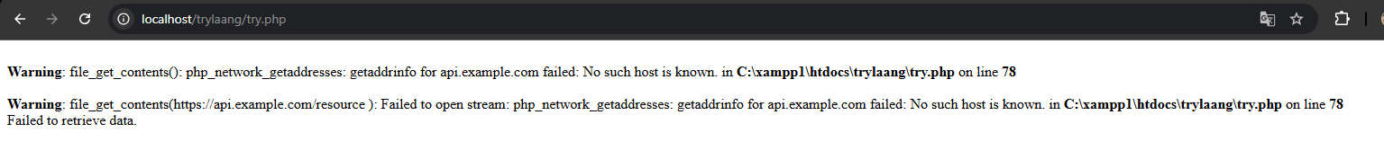1

- Error because the url maybe down or cannot access or DNS issues

2

Same as no1 system cannot access the url even I changed it to httpbin

3

it executed the file in the json url because it accept the request of the code

4

Cannot get the url that I enter.

5

It responses the url and convert it into string and the format want to display